### **Customer Account Summary Page Documentation**

**📍** Purpose

The Customer Account Summary page provides a comprehensive, interactive overview of customer accounts within the platform.  
It is designed to help users quickly understand the status, activity, and key metrics of customer accounts by combining dynamic filtering, KPI metrics, and multiple visualizations.  
Users can drill down into specific customer segments, regions, or timeframes, and all elements are tightly integrated for a seamless analytics experience.

### UI Elements and Their Functionality

**Header**

* **Page Title (**CUSTOMER ACCOUNT SUMMARY**):**  
  Clearly displays the purpose of the page.
* **Navigation Buttons (** Previous,Home, Next**):**  
  Allow users to move between different sections of the analytics dashboard.



### Filters



**We can filter the data using dropdowns by:**

* + - Customer name
    - Cust id
    - Status
    - Service Type
    - Business Unit
    - Business Line
    - Product name
* **Customer Dropdown:**

**Filtered view**

When a customer is selected from the dropdown menu, such as "ADMIN GENERAL DEPARTMENT," the following sections are updated to reflect the details of the chosen customer:

1. Customer Name: Displays the name of the selected customer (e.g., "ADMIN GENERAL DEPARTMENT").
2. Cust Id: Shows the unique identifier for the customer (e.g., "10083195").
3. Status: Indicates the current status of the customer account (e.g., "Inactive").
4. Service Type: Specifies the type of service associated with the customer (e.g., "Prepaid Card Services").
5. Business Unit: Lists the business unit to which the customer belongs (e.g., "St Vincent").
6. Business Line: Shows the business line related to the customer (e.g., "Fixed Voice").
7. Product Name: Displays the product name if available (e.g., "Null").

**Additionally, the summary metrics and visualizations are updated to reflect the filtered data**:

* Total Customer: The total number of customers (e.g., "1").
* Ceased: The number of ceased accounts (e.g., "1").
* Churn: The churn rate for the customer (e.g., "100.00%").

**Graphs and Tables:**

* **Customer Activations Over Time**: Shows the selected customer activated their account in 2005.
* **Average Tenure in Business Units (Months)**: Lists average tenure for business units (e.g., "Caribbean, St Vincent" with values "36.00" and "183.0").
* **Divisionwise Active and Ceased Accounts Details**: Indicates the customer is from "Grenada(Gri)" with "Activations: 1", "Ceased: 1", and "Churn: 100%".

These changes provide a detailed and focused view of the selected customer's account summary, including the specific year of activation and the current status of their account.

#### Multiple selects:

If we select multiple values the data will get filtered according to the selected values

For example, in customer id dropdown only the ids of selected customers are listed.

##### CustID dropdown:

When a customer ID is selected from the dropdown, the following details are updated and displayed accordingly: the customer's name, status, service type, business unit, business line, metrics panel, and charts. All these elements change to reflect the information specific to the selected customer ID.

##### Status dropdown**:**

When a status is selected from the dropdown, the displayed values are filtered to show only the data relevant to the selected account status. For example, if "Active" is chosen, the metrics and chart values will update to display information exclusively for active accounts.

Similarly, for other dropdowns, the values of metrics and graphs are filtered and displayed based on the selected options. This filtering can be applied to both single-select and multi-select options, ensuring that the displayed data accurately reflects the chosen criteria.

##### Metrics Panel



All metrics update in real-time with any filter or graph interaction.

### Graphs

###### 1.Account Activation over time:

When a specific year is clicked in the "Customer Activations Over Time" graph, the dashboard updates to reflect data relevant to that year. For example, clicking on the bar for the year 2003 will change the following sections:

1. **Total Customer**: Updates to show the number of customers activated in 2003.
2. **Average Tenure in Business Units (Months)**: Updates to display the average tenure for business units based on the selected year.
3. **Divisionwise Active and Ceased Accounts Details**: Adjusts to show activation data for different business divisions for the year 2003.

These updates provide a focused view of customer account activities for the selected year, allowing for detailed analysis of customer behavior and account status during that period.

###### 2.Average Tenure in Business Units (Months):

When a specific business unit is clicked in the "Average Tenure in Business Units (Months)" graph, the dashboard updates to reflect data relevant to that business unit. For example, clicking on "Caribbean Grenada" will change the following sections:

**Total Customer**: Updates to show the number of customers in the selected business unit.

**Ceased**: Displays the number of accounts that ceased in the selected business unit.

**Churn**: Shows the churn rate for the selected business unit.

**Customer Activations Over Time**: Updates to display the number of customer activations over the years for the selected business unit.

##### 3.Division wise Active and Ceased Accounts Details:

Adjusts to show activation, cessation, and churn data for the selected business unit

When a specific value is clicked in the "Divisionwise Active and Ceased Accounts Details" table, such as a business division, activation count, ceased count, or churn percentage, the dashboard updates to reflect data relevant to the selected option. For example:

* **Business Division**: Clicking on a specific division (e.g., "Grenada(Gr)") updates the metrics and graphs to show data for that division.
* **Activation Count**: Clicking on the activation count updates the dashboard to display details related to the number of activations.
* **Ceased Count**: Clicking on the ceased count updates the dashboard to show details about ceased accounts.
* **Churn Percentage**: Clicking on the churn percentage updates the dashboard to reflect churn data.

These updates provide a focused view of customer account activities based on the selected criteria, allowing for detailed analysis of customer behavior and account status within the chosen context.

Each graph provides interactive tooltips and info icons for deeper context.

## How Each Graph Works

| **Graph** | **What It Shows** | **X-Axis** | **Y-Axis** | **User Interaction & Filtering** |
| --- | --- | --- | --- | --- |
| Customer Activations Over Time | Bar chart of customer activations per year | Year | Total Customers | Click bar to filter by year |
| Customer Activations Over Time | Bar chart of customer activations per year | Year | Total Customers | Click bar to filter by year |
| Divisionwise Active and Ceased Accounts Details | Table of activations, ceased accounts, and churn rate by division | Business Division | Activations, Ceased, Churn | Click value to filter by division, activations, ceased, or churn |

## Cross-Filtering and Interactive Behavior

* **Any filter or graph click acts as a dimension filter.**  
  These filters are stored in a dimension_filter_store and are cumulative until reset.

**When a user clicks on any graph point, a dimension filter is applied (stored inside the dimension_filter_store):**

* **Customer Activations Over Time** → Filters by year.
* **Average Tenure in Business Units (Months)** → Filters by business unit.
* **Divisionwise Active and Ceased Accounts Details** → Filters by division, activations, ceased accounts, or churn rate

## Element Changes Summary (on Filter Activation)

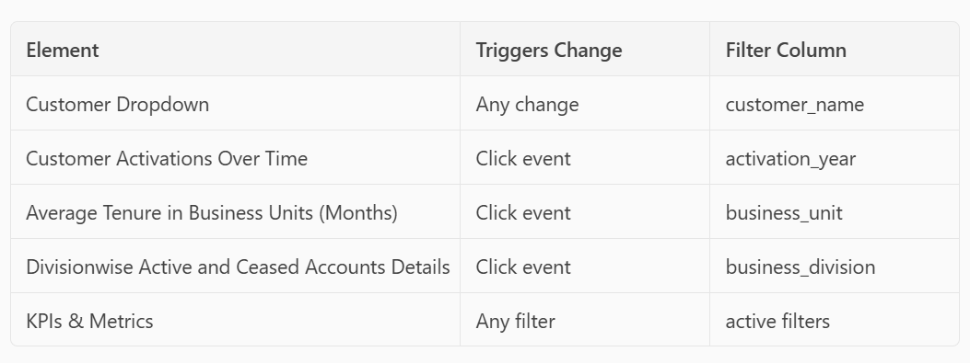

## Technical Notes

* **Cross-Filtering:**  
  All graph and KPI updates are managed through a central filter store, ensuring that any combination of filters produces a consistent, accurate view.
* **Callbacks:**
  + update_sub_queries() triggers all graph reloads.
  + update_metrics() triggers all KPI reloads.
* **SQL Performance:**  
  All SQL queries are dynamically rebuilt to include the latest filter state, ensuring optimal performance and accuracy.
* **Reset Mechanism:**  
  On reset, the dimension_filter_store is cleared and all visuals return to their default, unfiltered state.

## Summary

The Customer Account Summary page is a highly dynamic, interactive analytics dashboard where:

* Every graph is both visual and interactive—clicks apply cross-filters.
* Each graph click acts as a new filter for all other graphs + KPIs.
* Customer dropdown filters globally across the page.

KPIs and graphs are always in sync, reflecting the current filter context.

* Users can explore data by customer, status, region, time, or activity—individually or in combination.
* All filters are cumulative and cleared by the Reset button.
* Navigation is intuitive, allowing seamless movement across the dashboard.